Procurement System

Functional Specifications

: Version 0.2

**Contract No :**

**Customer Code :** NCS

**Version No :** Version 0.1

**Date Prepared :** 19 Apr. 12

**File Name :** Procurement System_FS.doc

**Prepared by :** Cheng Zhang, NCS

**Reviewed by :**

Revision History

|  |  |  |  |  |
| --- | --- | --- | --- | --- |
| Version | Effective Date | Summary of Change | Prepared by | Approved by |
| 0.1 | 19/04/2012 | Draft Version created | Cheng Zhang |  |
|  |  |  |  |  |
|  |  |  |  |  |
|  |  |  |  |  |

TABLE OF CONTENTS

1 Introduction 4

1.1 Purpose 4

1.2 Scope 4

1.3 Definitions, Acronyms and Abbreviations 4

1.4 References 4

2 Business background 5

2.1 Business Goals 5

2.2 Key Business Processes 5

2.3 Statutory Requirements 5

3 OBJECTIVES OF SYSTEM 5

3.1 Key Objectives 5

3.2 System Features 5

4 OVERALL DESCRIPTION OF SYSTEM 6

4.1 System Overview 6

4.2 Order process overview 6

5 Scrren Access 7

6 DATABASE SETUP 8

6.1 Data Dictionary 8

6.2 Data Model 8

7 SYSTEM/OPERATING ENVIRONMENT 8

# Introduction

## Purpose

This document aims to provide the requirement specifications for NCS Procurement System. It also describes non-functional requirements and data dictionary, as well as data relations.

## Scope

The following is the scope and list of features of Procurement system:

* Add, modify and delete NCS product information.
* Add, modify and delete Optus order information.
* Navigate through the system to search for product and order information.

## Definitions, Acronyms and Abbreviations

|  |  |
| --- | --- |
| **Term, Acronyms and Abbreviations** | **Definition** |
| ACM | Access Control Management |
| PO | Purchase Order |
| PS | Procurement System |
| AA | Authentication and Authorization |

## References

|  |  |  |  |  |  |  |
| --- | --- | --- | --- | --- | --- | --- |
| No. | Author | Title | Reference | Version no. | Date | Pages |
| 1 | Cheng Zhang | Procurement System GUI 0.1.pdf |  | 0.1 | 20 Apr 2012 | 7 |
| 2 | Cheng Zhang | ACM User Guide.pdf | TBC |  |  |  |

# Business background

## Business Goals

The Procurement System aims to assist NCS Corp in maintaining the order process, stock tracking etc. The system acts as a central repository/inventory for procurement between NCS customer (Optus) and vendor (Lenovo).

## Key Business Processes

The key business process is to serve as repository of products and orders to facilitate NCS procurement maintenance. It helps to organise the product information from the vendor (Lenovo) and keep track of orders from Optus.

## Statutory Requirements

N/A

# OBJECTIVES OF SYSTEM

## Key Objectives

The key objective of the system is to fulfil the key business process by providing a solution to record and track product and order of the procurement.

The system is to provide an effective way of recording and tracking product and order information. It also acts as a central repository for the information required for procurement between NCS supplier (Lenovo) and customer (Optus).

## System Features

Product

The system acts as a central repository of product list from Lenovo. It allows the NCS administrator(s) page to add new, modify and delete existing product etc. For each product, the air freight and mark up percentage can be customized individually.

Order

The system allows the users to search and maintain orders. The NCS Administrator(s) will be responsible for updating the order information (e.g. placing a new order based on Optus PO, recording the order status based on the order delivery ETA etc.). For each order, the NCS Administrator(s) can add/modify/delete product, and the price will be calculated accordingly the air freight is chosen. In the order page, the NCS Administrator(s) can also record the ETA and order status, which will assist the former in controlling the delivery timeframe to Optus.

In addition, there will be an export function, which exports the order details in Excel file format to facilitate in the expedition of enquiries between NCS other parties (e.g. Optus IT Shop, Lenovo etc).

# OVERALL DESCRIPTION OF SYSTEM

## System Overview

The Procurement System is a stand-alone web-based solution that enables NCS to effectively manage product and orders. It also captures the stock and order tracking information.

There are two user groups of the SOL:

|  |  |
| --- | --- |
| User Group | Functions/.Scope of use |
| Optus IT Shop | The staffs from Optus IT Shop are able to view all the available products as well as the order status based on Optus PO. |
| NCS Administrator | The NCS Administrators maintains the product, order and user administration. |

## Order process overview



1.0 Optus submits a PO to NCS to confirm an order.

2.0 NCS Administrator(s) checks the stock availability, and order from Lenovo whenever necessary.

3.0 NCS Finance provides NCS PO to Optus.

# Scrren Access

Refer to Section 1.4 of the document for the system GUI mockup.

The two main user groups, which will be granted access to the Procurement System, are the NCS Administrator and Optus IT Shop. The NCS Administrator will be granted full functions’ access to the system.

As for the Optus IT Shop, the former will only have access to the search function for both Product and Order, with certain fields which will be made also transparent to them. The mock up screens below illustrated the limited fields which will be exposed to the Optus IT Shop user group:

| **Screen Page** | Optus IT Shop |
| --- | --- |
| Product - Search |  |
| Order - Search |  |

# 

# DATABASE SETUP

## Data Dictionary

There are three tables in this Procurement System.

1. Table: TBL_PS_PRODUCT

This table contains information of product in details.

|  |  |  |  |
| --- | --- | --- | --- |
| **Column** | **Data Type** | **Description** | **Constraints** |
| PROD_ID | VARCHAR(45) | Primary Key | Not null |
| PROD_NUM | VARCHAR (45) | Product number | Not null |
| PRODUCT_DESC | VARCHAR (100) | Product description |  |
| PROD_STATUS | VARCHAR (45) | Product status | Active, Inactive, Obsolete |
| PRODUCT_QUANTITY | VARCHAR (45) | Product quantity in stock |  |
| UNIT | VARCHAR (45) | Unit of the product | EA |
| NCS_PRICE | float | NCS price of the product |  |
| OPTUS_PRICE | float | Optus price of the product |  |
| PERCENTAGE | float | The mark up percentage of the product |  |
| AIR_FREIGHT | float | Air freight fees of the product |  |
| UPDATED_DT | DATETIME | last update timestamp |  |
| UPDATE_BY | VARCHAR(45) | last update user name |  |

1. Table: TBL_PS_ORDER

This table contains information of order in detail.

|  |  |  |  |
| --- | --- | --- | --- |
| **Column** | **Data Type** | **Description** | **Constraints** |
| ORDER_ID | VARCHAR (45) | Primary Key | Not null |
| OPTUS_PO_NUM | VARCHAR (45) | Optus PO Number |  |
| NCS_PO_NUM | VARCHAR (45) | NCS PO Number |  |
| LENOVO_ORDER_NUM | VARCHAR (45) | Lenovo order number |  |
| ETA | DATETIME | Estimate time of arrival |  |
| ORDER_STATUS | VARCHAR (45) | Order status | Not Received, Partly Received, Fully Received |
| ORDER_AMOUNT | VARCHAR (45) | Total order amount |  |
| DATE_RECEIVED | DATETIME | Date received |  |
| UPDATED_DT | DATETIME | last update timestamp |  |
| UPDATE_BY | VARCHAR(45) | last update user name |  |

1. Table: TBL_PS_ORDER_DETAIL

This table contains relationship between table order and product. I.e. what products are exist in this order

|  |  |  |  |
| --- | --- | --- | --- |
| **Column** | **Data Type** | **Description** | **Constraints** |
| ORDERID | VARCHAR (45) | Order ID | Not null, system auto generate (by sequence) |
| PRODUCTID | VARCHAR (45) | Product ID | Not null, used to mapping TBL_PS_PRODUCT.PROD_ID |
| ORDER_QUANTITY | VARCHAR (45) | How many product been ordered |  |
| IS_AIR_FREIGHT | BOOLEAN | Is this product need air freight | 0 or 1 |
| ETA | DATETIME | Estimate time of arrival |  |
| ORDER_STATUS | VARCHAR (45) | Order status | Not Received, Partly Received, Fully Received |
| ORDER_AMOUNT | VARCHAR (45) | Total order amount |  |
| DATE_RECEIVED | DATETIME | Date received |  |
| UPDATED_DT | DATETIME | last update timestamp |  |
| UPDATE_BY | VARCHAR(45) | last update user name |  |

## Data Model

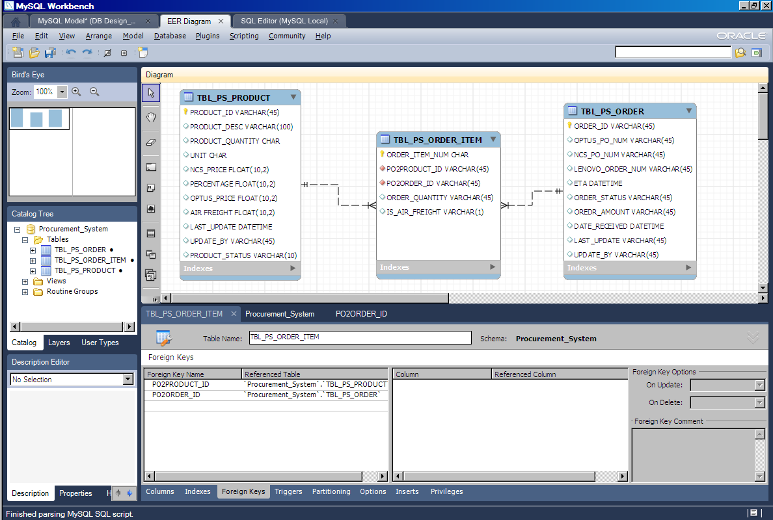

# SYSTEM/OPERATING ENVIRONMENT

The Procurement System is to be deployed via the web technology thus all users are required to access the system via a web browser.

The system software required for the servers and client machines are as follow:

**Web Server**

Apache Tomcat web server

**Database Server**

MySQL 5.0

**Client Workstations**

Browser – IE 6.0 onwards

Latest Java Virtual Machine